FIRE SAFE MARIN
DOCUMENT MANAGEMENT
RECORDS RETENTION & DESTRUCTION POLICY
Adopted February 14, 2014

1. Policy and Purposes

This Policy represents the policy of Fire Safe Marin with respect to the retention and destruction of documents and other records, both in hard copy and electronic media (which may merely be referred to as “documents” in this Policy). Purposes of the Policy include (a) retention and maintenance of documents necessary for the proper functioning of the organization as well as to comply with applicable legal requirements; (b) destruction of documents which no longer need to be retained; and (c) guidance for the Board of Directors, officers, staff and other constituencies with respect to their responsibilities concerning document retention and destruction. Notwithstanding the foregoing, the organization reserves the right to revise or revoke this Policy at any time.

2. Administration

2.1 Appointment and Responsibilities of the Administrator. The organization’s “President, Executive Vice President, Secretary, Treasurer, Etc., shall be the administrator (“Administrator”) in charge of the administration of this Policy.
The President may also designate another member to act as Administrator.

2.1.1 Duties of Secretary. The Secretary shall “Be custodian of the records and of the seal of the Corporation and see that the seal is affixed to all duly executed documents, the execution of which on behalf of the Corporation under its seal is authorized by law or these Bylaws.” Bylaws of Fire Safe Marin State Section 4.8 Duties Of Secretary Pg. 9.

The Administrator’s responsibilities shall include supervising and coordinating the retention and destruction of documents pursuant to this Policy and particularly the Document Retention Schedule included below. The Administrator shall also be responsible for documenting the actions taken to maintain and/or destroy organization documents and retaining such documentation. The Administrator may also modify the Document Retention Schedule from time to time as necessary to comply with law and/or to include additional or revised document categories as may be appropriate to reflect organizational policies and procedures. The Administrator is also authorized to periodically review this Policy and Policy compliance with legal counsel and to report to the Board of Directors as to compliance. The Administrator may also appoint one or more assistants to assist in carrying out the Administrator’s responsibilities, with the Administrator, however, retaining ultimate responsibility for administration of this Policy.
2.2 Responsibilities of Constituencies. This Policy also relates to the responsibilities of board members, staff, volunteers and outsiders with respect to maintaining and documenting the storage and destruction of the organization’s documents. The Administrator shall report to the Board of Directors (the board members acting as a body), which maintains the ultimate direction of management. The organization’s staff shall be familiar with this Policy, shall act in accordance therewith, and shall assist the Administrator, as requested, in implementing it. The responsibility of volunteers with respect to this Policy shall be to produce specifically identified documents upon request of management, if the volunteer still retains such documents. In that regard, after each project in which a volunteer has been involved, or each term which the volunteer has served, it shall be the responsibility of the Administrator to confirm whatever types of documents the volunteer retained and to request any such documents which the Administrator feels will be necessary for retention by the organization (not by the volunteer). Outsiders may include vendors or other service providers. Depending upon the sensitivity of the documents involved with the particular outsider relationship, the organization, through the Administrator, shall share this Policy with the outsider, requesting compliance. In particular instances, the Administrator may require that the contract with the outsider specify the particular responsibilities of the outsider with respect to this Policy.

3. Suspension of Document Destruction; Compliance. The organization becomes subject to a duty to preserve (or halt the destruction of) documents once litigation, an audit or a government investigation is reasonably anticipated. Further, federal law imposes criminal liability (with fines and/or imprisonment for not more than 20 years) upon whomever “knowingly alters, destroys, mutilates, conceals, covers up, falsifies, or makes a false entry in any record, document, or tangible object with the intent to impede, obstruct, or influence the investigation or proper administration of any matter within the jurisdiction of any department or agency of the United States … or in relation to or contemplation of any such matter or case.” Therefore, if the Administrator becomes aware that litigation, a governmental audit or a government investigation has been instituted, or is reasonably anticipated or contemplated, the Administrator shall immediately order a halt to all document destruction under this Policy, communicating the order to all affected constituencies in writing. The Administrator may thereafter amend or rescind the order only after conferring with legal counsel. If any board member or staff member becomes aware that litigation, a governmental audit or a government investigation has been instituted, or is reasonably anticipated or contemplated, with respect to the organization, and they are not sure whether the Administrator is aware of it, they shall make the Administrator aware of it. Failure to comply with this Policy, including, particularly, disobeying any destruction halt order, could result in possible civil or criminal sanctions. In addition, for staff, it could lead to disciplinary action including possible termination.

4. Electronic Documents; Document Integrity. Documents in electronic format shall be maintained just as hard copy or paper documents are, in accordance with the Document Retention Schedule. Due to the fact that the integrity of electronic documents, whether with respect to the ease of alteration or deletion, or otherwise, may come into question, the Administrator shall attempt to establish standards for document integrity, including guidelines for handling electronic files, backup procedures, archiving of documents, and regular checkups of the reliability of the system; provided, that such standards shall only be implemented to the extent that they are reasonably attainable considering the resources and other priorities of the organization.

5. Privacy. It shall be the responsibility of the Administrator, after consultation with counsel, to determine how privacy laws will apply to the organization’s documents from and with respect to employees and other constituencies; to establish reasonable procedures for compliance with such privacy laws; and to allow for their audit and review on a regular basis.

6. Emergency Planning. Documents shall be stored in a safe and accessible manner. Documents that are necessary for the continued operation of the organization in the case of an emergency shall be regularly duplicated or backed up and maintained in an off-site location. The Administrator shall develop reasonable procedures for document retention in the case of an emergency.

7. Document Creation and Generation. The Administrator shall discuss with staff the ways in which documents are created or generated. With respect to each employee or organizational function, the Administrator shall attempt to determine whether documents are created which can be easily segregated from others, so that, when it comes time to destroy (or retain) those documents, they can be easily culled from the others for disposition. For example, on an employee-by-employee basis, are e-mails and other documents of a significantly non-sensitive nature so that they might be deleted, even in the face of a litigation hold with respect to other, more sensitive, documents? This dialogue may help in achieving a major purpose of the Policy -- to conserve resources -- by identifying document streams in a way that will allow the Policy to routinely provide for destruction of documents. Ideally, the organization will create and archive documents in a way that can readily identify and destroy documents with similar expirations.
8. Document Retention Schedule
The terms “records” and “records retention” include hard paper copy, computer disks, microfilm, scanned or digitized copies, magnetic and visual media, and such other electronic communications.

The activities of non-profit organizations often produce valuable intangible property that should be protected to preserve its value. The various certificates, licenses, assignments, publication agreements, copyright and trademark registrations, royalty records, and other background material should be treated and retained as Permanent records.

9. Destruction of records reached or are beyond required “Retention Period.”

All records that are not required to be retained permanently shall be permanently destroyed at the end of the retention period.
Record Retention
The following table* indicates the minimum requirements and is provided as guidance to in following FIRE Safe Marin’s document retention policy. Statutory requirements.

Document Type Retention Period

Accounting and Finance
Accounts Payable 7 years
Accounts Receivable 7 years
Annual Financial Statements and Audit Reports Permanent
Bank Statements, Reconciliations & Deposit Slips 7 years
Canceled Checks – routine 7 years
Canceled Checks – special, such as loan repayment Permanent
Credit Card Receipts 3 years
Employee/Business Expense Reports/Documents 7 years
General Ledger Permanent
Interim Financial Statements 7 years

Contributions/Gifts/Grants
Contribution Records Permanent
Documents Evidencing Terms of Gifts Permanent
Grant Records 7 yrs. after end of grant period

Corporate and Exemption
Articles of Incorporation and Amendments Permanent
Bylaws and Amendments Permanent
Minute Books, including Board & Committee Minutes Permanent
Annual Reports to Attorney General & Secretary of State Permanent
Other Corporate Filings Permanent
IRS Exemption Application (Form 1023 or 1024) Permanent
IRS Exemption Determination Letter Permanent
State Exemption Application (if applicable) Permanent
State Exemption Determination Letter (if applicable) Permanent
Licenses and Permits Permanent
Employer Identification (EIN) Designation Permanent

Correspondence and Internal Memoranda
Hard copy correspondence and internal memoranda
relating to a particular document otherwise addressed
in this Schedule should be retained for the same
period as the document to which they relate.

Hard copy correspondence and internal memoranda
relating to routine matters with no lasting significance Two years

Correspondence and internal memoranda important to
the organization or having lasting significance Permanent, subject to review

Electronic Mail (E-mail) to or from the organization
Electronic mail (e-mails) relating to a particular document
otherwise addressed in this Schedule should be retained
for the same period as the document to which they relate,
but may be retained in hard copy form with the document
to which they relate. I Mary hello Heidi Ellen

E-mails considered important to the organization or
of lasting significance should be printed and stored
in a central repository. Permanent, subject to review

E-mails not included in either of the above categories 12 months

Electronically Stored Documents
Electronically stored documents (e.g., in pdf, text
or other electronic format) comprising or relating to
a particular document otherwise addressed in this
Schedule should be retained for the same period
as the document which they comprise or to which
they relate, but may be retained in hard copy
form (unless the electronic aspect is of significance).

Electronically stored documents considered important
to the organization or of lasting significance should
be printed and stored in a central repository (unless
the electronic aspect is of significance). Permanent, subject to review

Electronically stored documents not included in either
of the above categories Two years

Contract Employees
Contract Records 10 years after contract ends

Insurance
Property and General Liability Insurance Policies Permanent
Errors and Omissions Insurance Permanent
Insurance Claims Records Permanent

Intellectual Property
The activities of nonprofit organizations often
produce invaluable intangible property that should
be protected to preserve its value. The various
certificates, licenses, assignments, publication
agreements, copyright and trademark registrations,
royalty records, and other background materials
should be treated and retained as permanent records. Permanent

Legal and Contracts
Contracts, related correspondence and other
supporting documentation. 10 years after termination
Legal correspondence Permanent

Management and Miscellaneous
Strategic Plans 7 years after expiration

Policies and Procedures Manual Current version with revision
history

Property
Real Property Leases Permanent

Tax
Tax exemption documents & correspondance Permanent
IRS Rings Permanent
Annual information returns – federal & state Permanent
Tax returns Permanent

Document Destruction
The Document Retention and Destruction Policy identifies the record retention responsibilities of staff, volunteers, members of the board of directors, and outsiders for maintaining and documenting the storage and destruction of the organization’s documents and records.

Once records, other than permanent records, have reached the end of their required retention period, the shall be permanently destroyed in manner suitable

*********

FORM 990

The Internal Revenue Service requires that all corporations in the United States file an income tax return this includes non-profit corporations. FORM 990 is the tax return form that non-profits use to report their charitable receipts for the year. A form 990 is to be used by any 501(c) organization. The IRS also has variations of form 990 such as 990-EZ based on the complexity and size of the charitable organization and their donations for the year

APPENDIX

Material stored at trailer at Mill Valley Fire Department

Reference the following photo:

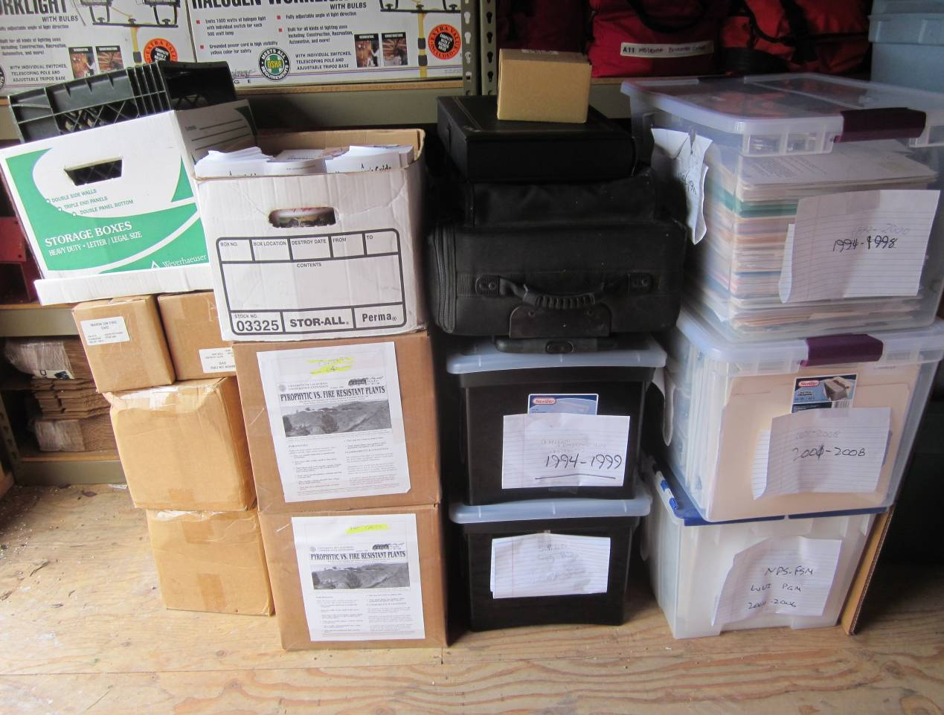

Stack #1 (from the right) - ignore each box’s label in the photo
- Bottom box
  - Binders with material related to grants (early 2000s)
- Second from bottom
  - Binders & files f or 1992-2000
  - Minutes, liability insurance info, financial info: budget reports, treasurer reports, checking account statements, cancelled checks
- Top box
  - Binders & files f or 2001-2008
  - Minutes, liability insurance info, tax returns, financial info: budget reports, treasurer reports, checking account statements, cancelled checks

Stack #2 (from the right) - ignore each box’s label in the photo
- Bottom box
  - General organizational and reference material: by-laws, address lists, past programs, some grant information, etc.; Board manual, Board of Directors Handbook (1997), two awards (1998 & 2003)
  - Empty hanging folders and manila folders
- Second from bottom
  - Empty binders and folders
- Third from bottom
  - Projector in roller-suitcase style case
- Top box – really a black carrying case labeled “Corporate records”
  - Articles & Exemptions; Minutes & Roles; By-laws; Membership Certificate
- Very top (small cardboard box):
  - Spare bulb for the projector

Stack #3 (from the right)
- All three boxes: “Pyrophytic vs. Fire resistant Plants” brochure
- Top box also has some copies of “Homeowners Guide to Fire Safe Practices in Marin County”

Stack #4 (from the right)
- Bottom two boxes
Mostly: “Homeowners Guide to Fire Safe Practices in Marin County” a few Fire Safe Marin brochures
- Next up, two boxes (next to each other): “Marin on Fire” DVDs
- Top ‘storage’ box with ‘milk case’ - both are empty

Reference the following photo:

From the right:
- Two large plastic bags with posters
- Blue carrying case with tri-fold display
- Two tri-fold displays on black cardboard

